

V 1.0
Oct 2025
XStep Design Specification
SMPL: IBC Concentrate Table

Table of Contents
1 Purpose 3
2 Overview 3
3 Reasons for Developing 4
4 Authorization 4
5 Assumptions/Dependencies 4
6 Validation Checks 4
7 Xstep Layout Design 5
8 Configuration Specifications 5
9 Test Scenarios 5
10 Revision History 6

Purpose
This document outlines the design, as well as the configuration specifications for the XStep “SMPL: IBC Concentrate Table”.

Overview
The purpose of the IBC Concentrate Table XStep is to summarize the critical raw material concentrate information linked to the process order and ensure the correct staging of components for the automated buffer preparation. This XStep functions as a digital gateway to verify that the physical materials connected to the IBC skid match the requirements of the 50 mM Tris, pH 7.4 recipe for example.
The XStep contains the following main input parameters:
- IV_HEADER - The default header text can be edited in SIMPL MBR to display the specific header text for the XStep.
- IV_INSTR - The default instruction text can be edited in SIMPL MBR to display the specific header text for the XStep.
- IV_SIGN – This can be changed in SiMPL MBR to author standalone signatures as part of the xstep.

The operator executes the “Get Materials” button:
- Get Materials - Function Button
The button is linked to the function module ZSMPL_FM_GET_WT_ITMS_BY_TY_EBR that retrieves the raw materials and related info listed in the BOM.
The operator can confirm the following fields and their values:
- Material - Output
- Material Description – Output.
- Batch No. - Input field with defaulted batch value from the BOM, if assigned.
- Exp. Date - Input field with defaulted batch expiry date, if batch is assigned in the BOM.
The operator enters the Inlet No.:
- Inlet No - Input.
The process order is generated, and during the setup phase of the IBC operation, the operator utilizes the XStep to record batch-specific data for the concentrates.

Functional Design
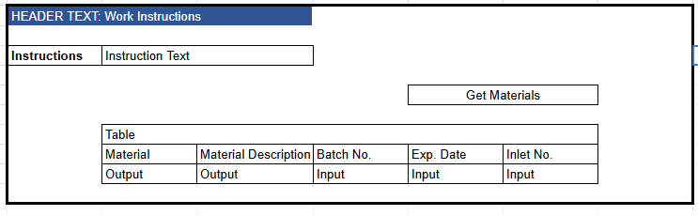

Reasons for Developing
The IBC Concentrate Table XStep serves as a record of the critical raw materials staged for the automated buffer preparation process. The XStep retrieves and displays the required component details linked to the recipe, namely the Material Description, and Inlet Number, to ensure the correct concentrates are utilized. It mandates the recording of the Material Number, Batch Number and Expiration Date for each concentrate to maintain a verified link between the physical materials and the digital process order. After execution of the XStep, these details provide a compliant audit trail that confirms the solution was manufactured using the specific parameters and materials required to meet the final product specifications.

Authorization
N/A

Assumptions/Dependencies
N/A

Validation Checks
N/A

Xstep Layout Design
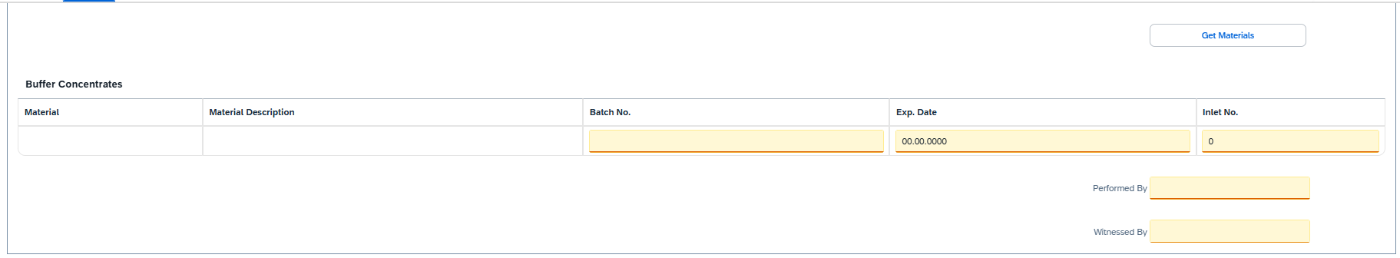

Configuration Specifications
N/A

Test Scenarios

Step No. | Action / Description | Expected Result | Actual Result | Pass/ Fail  Test Issue Log #
1 | Create and Release a Process Order with the pre-configured SiMPL Master Recipe and the relevant Production Version | Process Order created and Released containing SMPL IBC Concentrate Table | Process Order created and Released containing SMPL IBC Concentrate Table | Pass
2 | Open the EBR, and navigate to SMPL IBC Concentrate Table | The EBR for the selected Process Order and Control Recipe opens successfully without any errors and the SMPL IBC Concentrate Table is visible | The EBR for the selected Process Order and Control Recipe opens successfully without any errors and the SMPL IBC Concentrate Table is visible | Pass
3 | Verify that the value/text entered in parameter IV_HEADER and parameter IV_INSTR in SiMPL MBR appears correctly in the XStep header | Header and instruction text are displayed as authored in SiMPL MBR | Header and instruction text are displayed as authored in SiMPL MBR | Pass
4 | The operator executes the “Get Materials” button. | The rows populated in the IBC Concentrate table from the BOM’s raw materials include the Material No., Description, and Batch information if a batch is assigned in the BOM. | The rows populated in the IBC Concentrate table from the BOM’s raw materials include the Material No., Description, and Batch information if a batch is assigned in the BOM. | Pass
5 | The operator input the material number required in the Material field | The material number is accepted and the material description is automatically populated in the Material description field. | The material number is accepted and the material description is automatically populated in the Material description field. | Pass
6 | The operator inputs a vali batch number required in the Batch No. Field if Batch number is not retrieved from the BOM. | The batch number input is accepted when entered into the Batch No. field if Batch number is not retrieved from the BOM. | The batch number input is accepted when entered into the Batch No. field if Batch number is not retrieved from the BOM. | Pass
7 | The operator inputs a valid expiry date into the Expiry Date field if Expiry date is not retrieved from the batch. | A valid expiry date input is accepted when entered into the Exp. Date field if Expiry Date is not retrieved from the batch. | The expiry date input is accepted when entered into the Exp. Date field if Expiry Date is not retrieved from the batch.. | Pass
8 | The operator inputs the required inlet no into the Inlet No field | The inlet no input is accepted when entered into the Inlet No. field. | The inlet no input is accepted when entered into the Exp. Date field. | Pass

Revision History
Version No. | Description | Author | Date

